Individual Discovery Guide

Step 1: Start your discovery by accessing your Disciple Maker Index results

Step 2: First notice the number of responses
Prior to COVID-19, how many people would typically come to your parish on a weekend? A good rule of thumb for a survey sample is 10%. If your Mass-going population were 1,000 individuals and you had 100 responses to the Disciple Maker Index, that would be a satisfactory response from a statistical standpoint.

- How many total responses did you have from your parish? What strikes you about the response (e.g. lower than expected, higher than expected)?

Step 3: Scroll down and review the different reports.
- Each report has a brief description that explains the type of questions highlighted.
- Begin with “Key Drivers.” This report highlights some of the biggest factors that prompt a parishioner to indicate they would recommend their parish and say the parish is helping them grow spiritually as a Catholic.
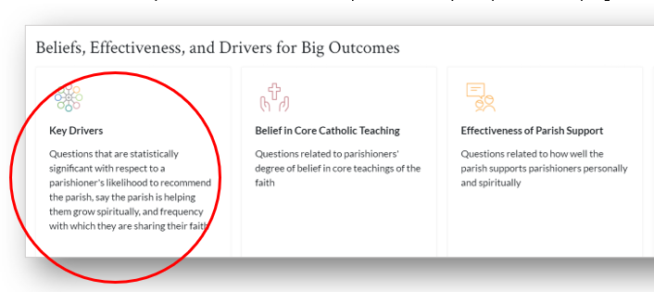

- You can see the full question by hovering over the bar graph with your mouse.
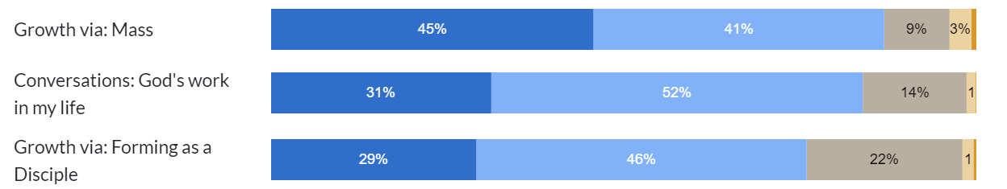

- You can also filter any question by using the filter boxes at the top of the report. For example, if you wanted to see how 18–25-year-old respondents felt about these questions, you could select “Age” in the first box and “18-25” in the second box. The results will then filter by only those who indicated they were in that age range.
Step 3: Capture your thoughts, questions, and insights as you review.
- Don’t edit yourself. Whatever comes to mind, jot it down. Questions, reactions, insights, confusion, capture it for later review and discussion with your fellow key parish leaders. To guide your discovery, below are some different prompts for you to consider.

Key Driver Report
- Which of the Key Drivers are strongest for your parish (i.e. the darkest blue)? From your perspective, why are these strongest for your parish?

- Which of the Key Drivers are the biggest opportunities for growth for your parish (i.e. the most gray-orange)? From your perspective, why are these the biggest opportunities for your parish?

From among the other reports:
- What questions did the feedback raise for you?

Report | Item | Observation/Question
EXAMPLE: Belief in Core Teaching | Scripture is the Word of God | I thought this would be higher for our parish
EXAMPLE: Sunday Experience | Music | I think this is because our choir hasn’t been singing during COVID

- What other items emerged as potential strengths for your parish?

- What other items emerged as potential opportunities for growth?

- What are some areas that you want to explore further?

- What are some of the most important insights to share with your fellow parishioners in a summary?

Two Important Reminders

This is for you: This document is to guide your individual reflection and discovery as a key parish leader. It does not need to be submitted. It is intended to help organize your thoughts as you discuss the information with your pastor and fellow key parish leaders.

Please do not forward this information: While this information is not a secret, the information shared with you as a key parish leader is sensitive. As leaders in your parish, it’s important to think about the best way to summarize and provide context on your Disciple Maker Index Results.
Thank You!

